Home network basics

Typical home network setup video

They consist at least of 2 networks

1. Public network from provider (cable, DSL provider)

Usually has a modem with input and output port

Then there is router where router is connected to modem

Components of a home network

**In addition to an integrated router, there are many different types of devices that might be connecting to a home network** for example:

Desktop computer

Gaming system

Smart tv system

Printers

Scanners

Security cameras

Telephones

Climate control devices

More and more household functions will rely on the network to provide connectivity and control

Home wireless local area network (WLAN)

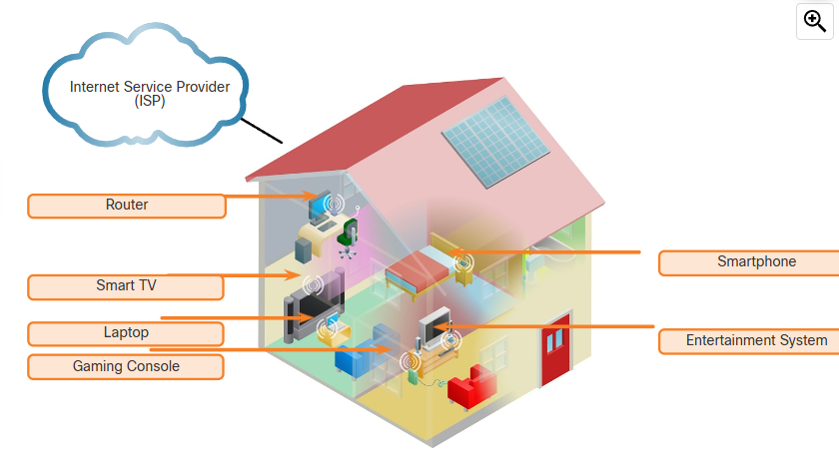

Typical home network routers

Small business and home routers typically have two primary types of ports:

ETHERNET PORT

**These ports connect to the internal switch portion of the router**

These ports are labaled ”ethernet” or “LAN”

**All devices connected to the switch ports are on the same network**

INTERNET PORT

**This port is used to connect the device to another network**

The internet port connects the router to a different network than the ethernet ports

**This port often used to connect to the cable or DSL modem in order to access the internet**

Many routers include a radio antenna and a build-in wireless access point

**Wireless devices are on the same local network as the devices that are physically plugged into the LAN switch ports**

The internet port is the only port that is on a different network

